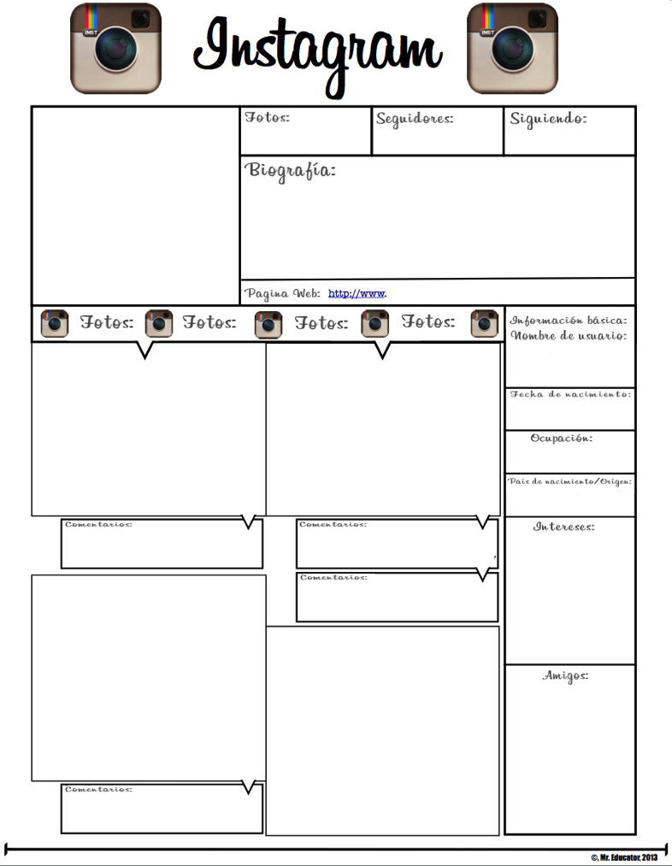

Number

Number

Number

Photo here:

Photo here:

Photo here:

Photo here:

Photo here:

Type here:

Type here:

Type here:

Type here:

Type here: 

Type here: 

Type here:

Type here:

Type here:

Type here:

Type here: